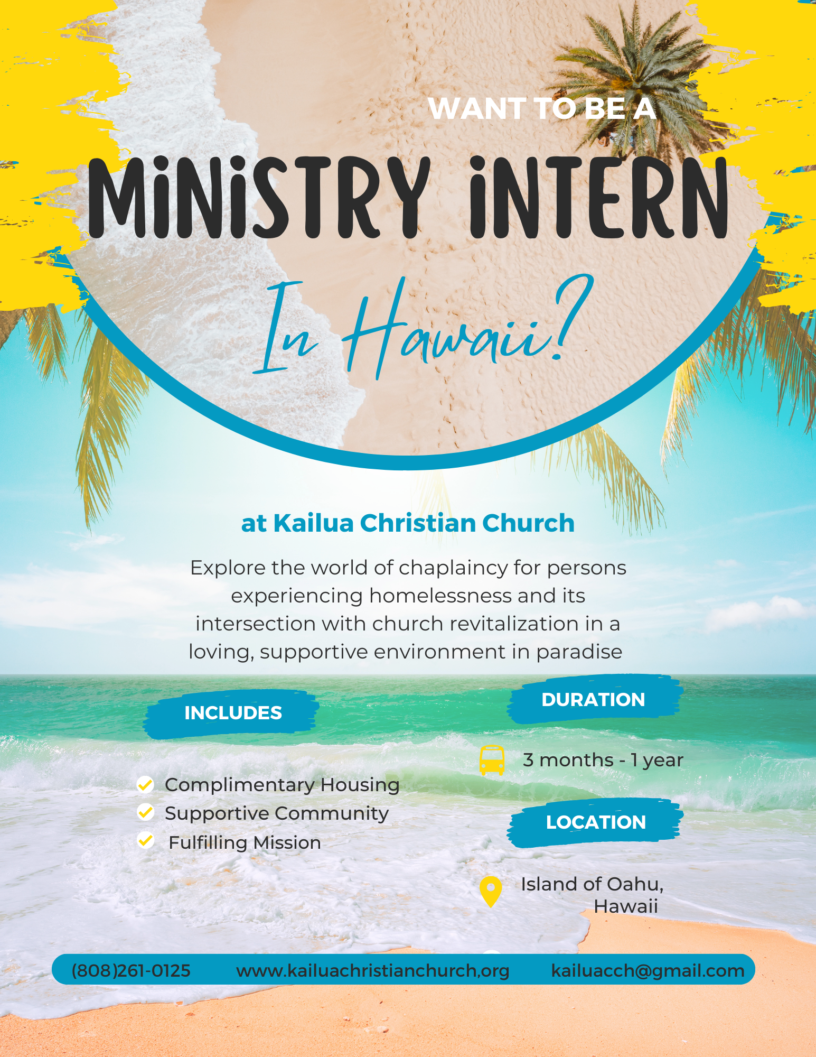

**Internship Site Description**

| Name | Kailua Christian Church Service Learning Community Internship |
| --- | --- |
|  | |
|  | |
| Location | 317 Manono St, Kailua, Hawaii |
|  | |
|  | |
| Website | [www](http://www.ucc.org/partners-in-service).kailuachristianchurch.org |
|  | |
|  | |
| Church Size  Denomination | 100  United Church of Christ |
|  | |
| PT / FT | FT 40 hours a week, PT 10-15 hours a week |
|  | |
| Duration | 3 months, June 1-August 17, 2025, or 1 year, June 1 2025-May 24, 2026 |
|  | |
| Type of Position  # of Positions | Volunteer - Paid Internship  6 |
|  | |
| Salary Basis | Volunteer Stipend, $300-500/month |
|  | |
| Benefits | Complimentary housing and utilities, complimentary weekly meals and groceries. Participants will live in dormitory-style rooms with two shared bathrooms, a kitchen, and lounge/study space. All participants will be provided bicycles to navigate the small beach town of Kailua and bus passes to reach site partnerships or other areas of the island recreationally. 4 weeks vacation for year long participants. |
|  | |
|  | |
| Language  Applicants | English, Japanese, Hawaiian  Applicants must be aged 20-25. Applicants must by studying relevant theological, biblical, social work, or nonprofit management coursework at an accredited institution. |
|  | |
|  |  |

**Mission and Learning Objectives**

**Summary of the Service Learning Community Internship**

Kailua Christian Church’s (KCC) service learning community is an exercise in preparation for the environment of ministerial job prospects in chaplaincy, local church pastorship, and international mission that participants may face upon graduating from their theological institutions. Additionally, for participants interested in international mission work, this is an enlightening environment to learn about Christianity in context of historically colonized populations.

Participants will be held in supportive discernment while they navigate their ministry direction by a community that has years of experience guiding Seminarians through their pastoral calls, as well as having access to and education from a variety of professional pastors and chaplains. The declining church is the fact of life for many seminary participants' future job prospects and has a huge impact on the durability of chaplaincy careers, as the funding and support for most chaplaincy jobs comes from local church facilitation. Further, Christianity in historically colonized contexts often operates differently than Christianity in majority Western contexts, and the nature of the globalized, post-colonial world will impact future pastoral job opportunities.

Participants will live in a Service Learning Community, collaborating with ministry peers to develop pastoral leadership and voice within local church and chaplaincy contexts. The program focuses on three key objectives:

1. Envisioning solutions for declining mainline churches, including contemporary worship and outreach.
2. Expanding chaplaincy with Hawaii's largest homeless service organization, The Institute for Human Services (IHS).
3. Exploring Christianity's role in historically colonized contexts to understand its impact on future ministry.

**Learning Objectives and Activities**Participants will engage in:

* Preaching or teaching quarterly and assisting Sunday worship.
* Designing and leading a Vacation Bible School (VBS) for keiki (ages 6–12).
* Designing and providing spiritual care programs at IHS’s Kilohana and Kalihi Uka Recovery House Shelters.
* Facilitating a monthly spiritual pā’ina lunch “talk story” after worship.
* Supporting KCC and IHS programs through advertising and outreach.
* Studying Christianity in post-colonial societies, with a focus on Hawaiian, Japanese, Filipino, and Micronesian contexts.
* Researching the connection between churches, chaplaincy, and social service systems.

**Program Goals**

* Develop pastoral leadership in church and community settings.
* Navigate the decline of mainline churches and its effect on chaplaincy.
* Develop proficiency in spiritual care for vulnerable populations.
* Analyze Christianity’s contextual practice in multicultural and colonized environments.

**Weekly Commitments (35–40 hours for summer, 10–15 for yearlong)**

* Weekly reflection dinner with the Service Learning Community and Committee.
* Monthly or on-call spiritual coaching with professional Spiritual Director.
* Weekly workshop with rotation of guest Pastors (summer only)
* Researching church and and its effect on social service systems (reading materials provided)
* Researching the effects of Christian colonization on indigenous and vulnerable populations, in particular common populations in Hawaii (reading materials provided)
* Researching chaplaincy to individuals experiencing homelessness, addiction, and mental illness (reading materials provided)
* Planning, advertising, and executing a Vacation Bible School for the week of July 28-August 1, 2025.
* Designing and facilitating a monthly spiritual pā’ina lunch “talk story” program with the congregation post-worship.
* Visiting and serving in a chaplaincy and/or social work capacity at the Institute for Human Services (homeless services)
* Both missions at the church or the shelters should intentionally integrate knowledge of cultural practices into ministry work.
* Maintaining social media presence for the purpose of advertising programs facilitated by the service learning community.
* All participants will be expected to attend and participate in traditional Sunday worship service weekly and provide a testimonial summary for the congregation at the conclusion of their program (summer) or on a quarterly basis (yearlong).
* All participants will be expected to attend at least 1 Council and/or Deacons meeting to help provide leadership insight.
* All participants will be expected to preach for a worship service or teach a Christian Education class for the church once (summer) or quarterly (year long) during their service.
* Participants will be expected to take at least 2 trainings on Hawaiian history, culture, and spirituality.

Duties may be tailored to student interests.

**Demographics of the Service Learning Community Site**

Kailua, Hawaii



Source 2020 Census

65 or older in Kailua 19.6%

5 or younger in Kailua 5.6%

Adult Day Care Centers in Kailua 2

Child Care Centers in Kailua 20

White 43.8%

Asian 20.3%

Two or more Races 28.9%

Owner occupied housing 74.5%

Median selected monthly owner cost-without a mortgage $695

Median gross rent $2,698

Persons in poverty 4.3% in Kailua

*Kailua is an affluent neighborhood of Oahu that, according to the census data, holds a low poverty rate and is highly residential. The demographics of Kailua Christian Church reflect the demographics of its surroundings in that we are a mostly middle class, ethnically Japanese community in the middle of a residential neighborhood. However, our demographics – as with most churches in 2025 – are aging at a much higher rate than our neighbors. Part of the mission of the Service Learning Community is to reflect and address this problem appropriately in context of the student participants’ intended pastoral or chaplaincy career.*

**Homelessness on Oahu 2023**

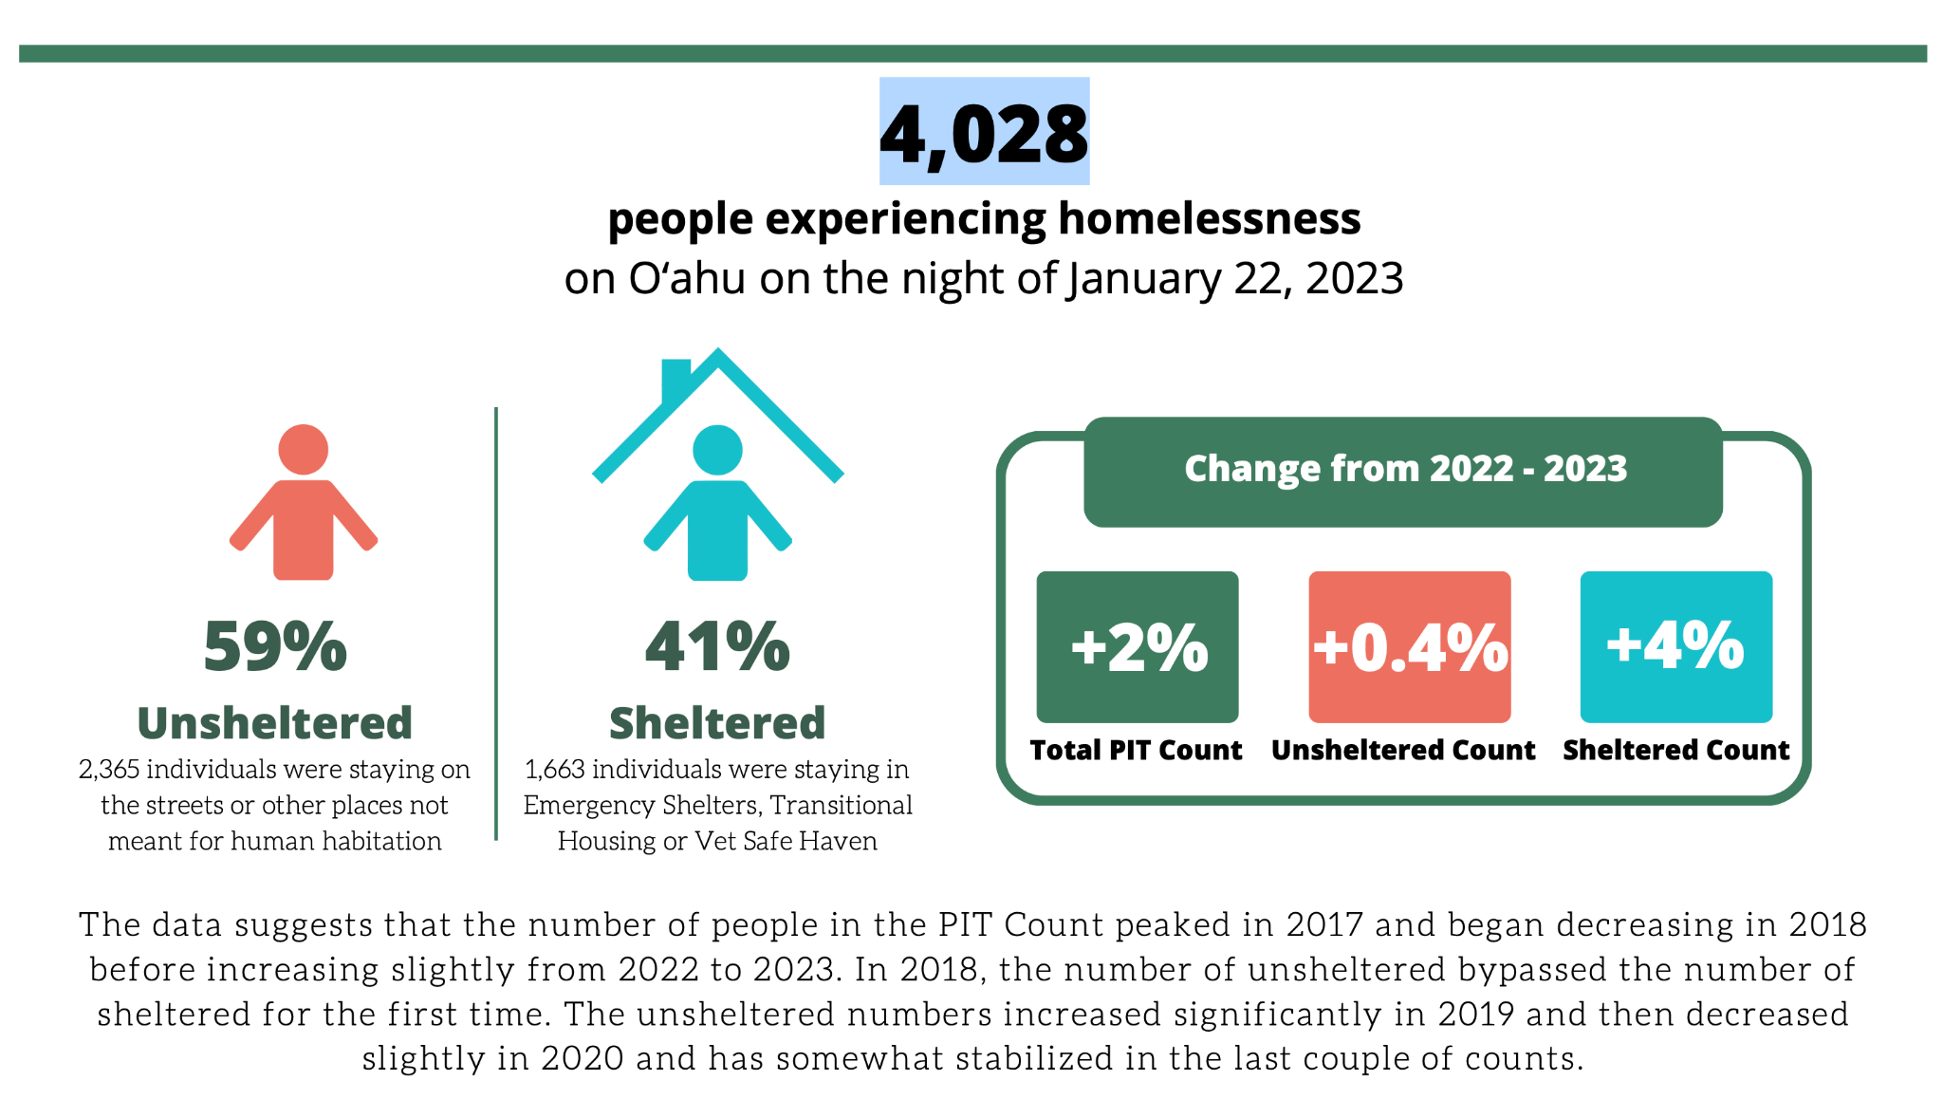

Source - Partners in Care Oahu:

<https://www.partnersincareoahu.org/pit>



<https://ihshawaii.org>

Hawaii holds the unfortunate statistic of being in the top 5 US states with the highest per capita population experiencing homelessness in the country. The Institute for Human Services (IHS) is the oldest and largest homeless services company in Hawaii. With 3 emergency shelters, over a dozen respite and transitional homes, and a staff of 200+ dedicated homelessness specialists, IHS provides a robust environment for seminarians considering chaplaincy to serve and imagine their futures as professional chaplains in a social services environment. Pastor Irene Willis Hassan of Kailua Christian Church is the former Director of Chaplaincy for IHS, and Connie Mitchell, current Executive Director of IHS, is the former Associate Pastor of Kailua Christian Church. Our church has a long standing relationship with this organization and Pastor Irene continues to serve as volunteer Chaplain for them every Friday with intention to expand the Chaplaincy through ecumenical partnerships and the Kailua Christian Church Service Learning Community.

**Membership of Kailua Christian Church**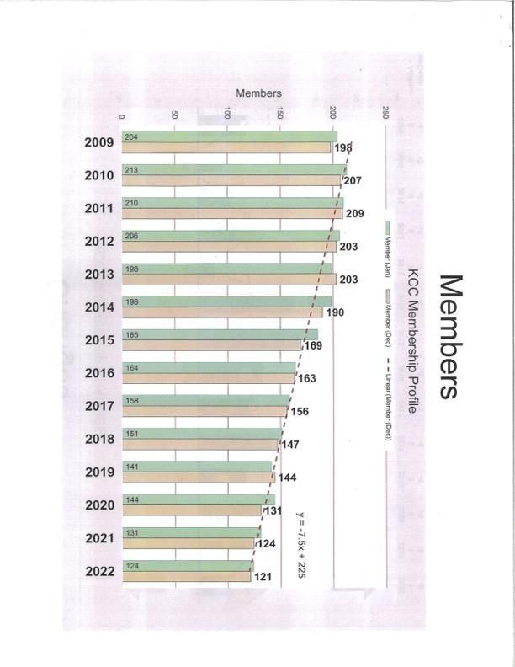

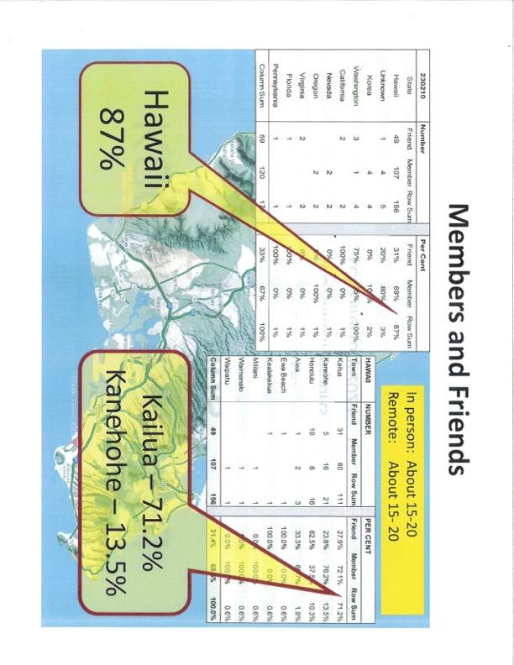

**Application for Service Learning Community Internship**

Kailua Christian Church

Full Legal Name: __________________________________

Preferred Name: ______________________________

Date of Birth: _______________

Gender: M ___F___ Non Binary ___ Prefer not to say ___

Phone Number: ___-___-____

Address: _____________________

_____________________

_____________________

_____________________

Are you most interested in the Pastoral Ministry, Chaplaincy, or International Mission Track?:

Pastoral Ministry __ Chaplaincy __ International Mission __ Other: ___________________________

If you play a musical instrument, please tell us which one(s):

________________________________________________________________________________

Do you have social media marketing or advertising skills?

________________________________________________________________________________

Do you have any disabilities that need to be considered for appropriate housing accommodations?:

________________________________________________________________________________

Dietary restrictions:

________________________________________________________________________________

Allergies:

________________________________________________________________________________

Medical conditions:

________________________________________________________________________________

We require all interns on our property to be medically insured. If you do not have health insurance, are you willing to sign up to receive complimentary medical insurance from UCC National Ministries?:

Y___ N___ N/A ___

Is your seminary or university offering any financial support for your internship? Please explain:

________________________________________________________________________________

The following questions are intended to help us get to know you. Please take up as much space as you feel is appropriate to answer the questions.

1.) Describe your overview understanding of Christian theology and mission:

2.) Describe why you are applying for this internship. Include information about what you think you will bring to the Service Learning Community and what you are expecting to take away from the experience:

3.) Describe your knowledge of Hawaiian history, culture, and spirituality. Have you ever experienced mission in a cultural environment different than your own?:

Mahalo for completing your application for the Service Learning Community at Kailua Christian Church! Please send the completed application to [kailuacch@gmail.com](mailto:kailuacch@gmail.com). Supplementary information including resume, links to articles and accomplishments, or references may also be attached. Questions may be directed to the same e mail address as above or by phone at (808)261-0125. The application period will be closed on March 7, 2025, and candidates will be interviewed and selected over the course of the following 2-3 weeks. Date for beginning of service, when selected candidates are expected to be on island and prepared to serve, will be June 1, 2025. 1-Year participants will be expected to remain in service until May 24, 2026, and 3 month participants will be expected to remain in service until August 17, 2025.